 | University of California at Berkeley  College of Engineering  Department of Electrical Engineering and Computer Science | 
EECS 150  Spring 2008 |  | P. C. McGeer  K. S. J. Pister
Problem Set #2:
Combinational Logic and HDLs
Assigned 1/31/2008,
Due 2/8/2008 at 2 PM

- The n-input parity function is defined as follows: out = 1 if and only if an odd number of the n inputs are 1. Draw the Karnaugh maps for the 2-input, 3-input, 4-input, and 5-input parity functions. Calculate the number of primes for a general n-input parity function, and the size of the minimum two-level circuit for an n-input parity function
Solution: The Karnaugh Maps for the 2, 3-, 4, and 5 input parity function are as follows:
0 | 1
1 | 0

0 | 1 | 0 | 1
1 | 0 | 1 | 0

0 | 1 | 0 | 1
1 | 0 | 1 | 0
0 | 1 | 0 | 1
1 | 0 | 1 | 0

0 | 1 | 0 | 1 |  | 1 | 0 | 1 | 0
1 | 0 | 1 | 0 |  | 0 | 1 | 0 | 1
0 | 1 | 0 | 1 |  | 1 | 0 | 1 | 0
1 | 0 | 1 | 0 |  | 0 | 1 | 0 | 1

And it’s pretty obvious from this that, for an n-input parity function, exactly half of the minterms are 1, and, further, that all the minterms are primes (and they are all essential). Since there are then exactly 2^{n-1} essential primes, each with n literals, the minimum sum-of-products representation will have 2^{n-1} n-input AND gates, and one 2^{n-1}-input OR gate, we have at least (n+1) 2^{n-1} literals. But in general, an m-input gate is realized by a tree of m-1 2-input gates, so we’ll have (n-1) 2^{n-1} + (2^{n-1}-1) 2-input gates.
- An alternate definition of the n-input parity function is given by the following recurrence equations:
P[0] = 0
P[n] = A[n] ⊕ P[n-1]
Where, as always, ⊕ represents the exclusive-or function. Design the 2-input, 3-input, 4-input, and 5-input parity functions suggested by these recurrence equations, and estimate the number of exclusive-or gates required for a general n-input parity function realized this way. Assuming that an exclusive-or gate is realized by three NAND gates, estimate the number of two-input nand gates for a general n-input parity function
Solution: In general, at the mth stage of the recurrence, we have:
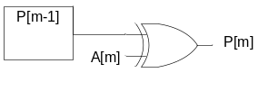
Where P[m-1] is the parity computation for inputs A[1]…A[m-1]. As a result, the contribution for each stage is one XOR gate. Even if we conservatively say that one XOR gate is equivalent to 8 literals (two inverters, two AND gates, one OR gate), we have at most 8n literals – far better than the sum-of-products representation.
The two approaches have not quite the same depth – the naïve two-level approach actually factors out to a depth (delay) of n + log n gates – log n for the ANDs and n for the OR. The recurrence-equation approach has depth n. However, there’s an approach with depth log n, shown here: compute parity for inputs A[1…n/2], and parity for inputs A[n/2+1….n], then XOR the results together.
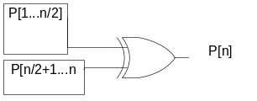

- The Evil Cardinal has taken 10 valiant Bears prisoner. He then offers the Bears a game: he will bury them all, in a line, up to their necks in sand so that each Bear will only be able to see the Bears in front of him. He will then place a red or white skullcap on the head of each Bear. Each Bear will then be required to call out the color of the skullcap on his own head. If at least nine of the 10 Bears call out the correct color, the Bears will all be set free; if more than one gets it wrong, they’re all dead. Each Bear can only call out “red” or “white”; no other communication is permitted. However, they can confer ahead of time to decide on a strategy. What strategy will permit the Bears to be set free, rather than suffering an ignominious fate (to add insult to permanent injury, the Cardinal is planning to execute the Bears with an Axe)?
Solution.The last Bear in line can see every skullcap but his own, and so he calls out “Red” if the Red skullcaps in front of him have odd parity, “White” if the Red skullcaps in front have even parity. He’s got a 50% chance of being wrong on the color of his own skullcap, but so what? One can be wrong, and he’s given all the other Bears enough information to be right.
To see this, consider the Bear immediately in front of the last Bear. The parity computed by the last Bear is the parity of all the caps in front of him XOR’d with his own cap. He knows the parity of all the caps (he just heard the last Bear yell it out) and he knows the parity of the caps in front. From this, he can deduce his own color, from the following table:
 | Global Parity Odd | Global Parity Even
Parity in Front Odd | White | Red
Parity in Fron Even | Red | White
Now consider the third Bear from the back in line. He knows three things: the parity of the caps in front of him, the parity of all the caps (except for the cap of the last Bear, which we’re ignoring), and the cap of the Bear behind him. And he knows the following equation must hold:
Parity of all caps = my cap is Red ⊕ Parity of caps ahead ⊕ Cap behind is Red
So this yields the following table:
 | Global Parity Odd | Global Parity Even
Parity in Front Odd, Cap Behind is Red | White | Red
Parity in Front Odd, Cap Behind is Red | Red | White
Parity in Front Even, Cap Behind is Red | White | Red
Parity in Front Even, Cap Behind is White | Red | White
This is of course our familiar three-variable parity function, with some change of names and variables!
Now consider the general case. The kth Bear from the end waits until he hears all k-1 Bears behind him call out their caps. From this, he knows three things: first, the global parity (from the original call; two, the parity behind him (he’s kept track as he’s heard the Bears behind him call out their colors correctly), and, three, the parity of caps in front of him. And he knows he must maintain the following invariant:
Parity of all caps = my cap is Red ⊕ Parity of caps ahead ⊕ Parity of caps behind
Which gives the following table

 | Global Parity Odd | Global Parity Even
Parity in Front Odd, Parity Behind Even | White | Red
Parity in Front Odd, Parity Behind Odd | Red | White
Parity in Front Even, Parity Behind Odd | White | Red
Parity in Front Even, Parity Behind Even | Red | White
Which again is the familiar parity function. Using these observations and this table, the Bears are able to defeat the Evil Cardinal. They then captured his Axe and, to prevent further violence of this type, mounted it on a wooden plaque where it remains today.
- Borriello & Katz, Problem 2.33
Solution: The key to the solution is to recognize that the minimum product-of-sums form for a Boolean function is the DeMorgan’s complement of the minimum sum-of--products form for the complement of the function. So, let’s take each part.
Part a: One solution here is our old friend parity,
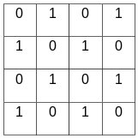
The sum-of-products here has eight terms of four literals each; the minimum product-of-sums is just the complement of even parity, which obviously also has eight terms of four literals each.
Part b: Many solutions, among them:
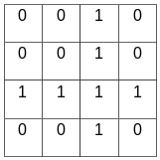
The minimum sum-of-products here is obviously xy + zw, and the minimum product-of-sums is (less obviously) (x + z)(x + w)(y+z)(y+w). To see this, note the minimum sum-of-products of the complement is x’z’ + x’w’ + y’z’ + y’w’, and just complement this form using De Morgan’s Law
Part c: From the above, the complement of any solution of Part b is a solution to part c. So:
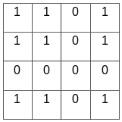
The minimum sum-of-products form for this function is x’z’ + x’w’ + y’z’ + y’w’, and the minimum product-of-sums is (x’+y’)(z’+w’)

- Borriello & Katz, Problem 2.40
Solution.
Part a:
i₀ | i₁ | Shift | o₀ | o₁
0 | 0 | 0 | 0 | 0
0 | 0 | 1 | 0 | 0
0 | 1 | 0 | 0 | 1
0 | 1 | 1 | 0 | 0
1 | 0 | 0 | 1 | 0
1 | 0 | 1 | 0 | 1
1 | 1 | 0 | 1 | 1
1 | 1 | 1 | 0 | 1
Part b:
in | Select | o₀ | o₁
0 | 0 | 0 | 0
0 | 1 | 0 | 0
1 | 0 | 1 | 0
1 | 1 | 0 | 1
Part c:
i₀ | i₁ | Select | out
0 | 0 | 0 | 0
0 | 0 | 1 | 0
0 | 1 | 0 | 0
0 | 1 | 1 | 0
1 | 0 | 0 | 1
1 | 0 | 1 | 0
1 | 1 | 0 | 1
1 | 1 | 1 | 1

- (Cascade multiplication). The goal of this problem is to design a four-bit by four-bit multiplier out of a basic component that adds two-one-bit numbers. In general, given n-bit numbers a and b, and c = a * b, we can write:
c[0] = a[0] b[0]
c[1] = a[1]b[0] + a[0][b[1]
c[2] = a[2] b[0] + a[0]b[2] + a[1] b[1] + carry_out(a[1]b[0] + a[0][b[1])…

The general picture is here (Figure 3.36, A 4 X 4 NMM (nonadditive multiply module), pg 192, Digital Computer Arithmetic by Joseph J.F. Cavanagh, 1984)
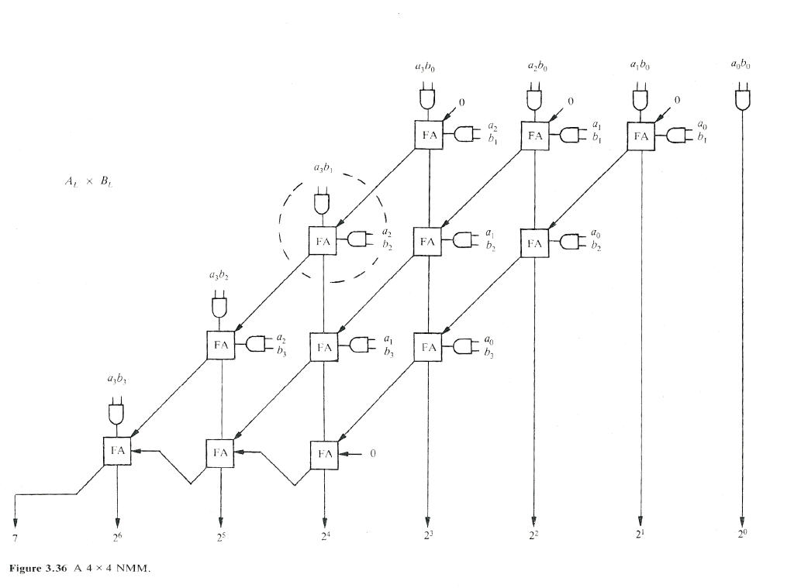
All the multiplication here is unsigned. First, derive the module FA (Full Adder) as a two-level function. This module takes 3 one-bit inputs a, b, c_in, and has two outputs, sum and c_out. Build the truth table for sum and c_out as Karnaugh maps, derive the optimal two-level implementation and implement this as a Verilog module. Next, write the module mult(A, B, result) using your full adder, where A and B are four-bit unsigned numbers and result is an 8-bit unsigned number.
Solution: The problem and its solution are taken from the web page http://www.bearcave.com/cae/cascade_mult.html. The solution is given with the following Verilog Code

module full_addr( a, b, c_in, c_out, sum );
input a, b, c_in;
output sum, c_out;

wire a1, a2, a3, a4;
wire c1, c2, c3, c4;

assign a1 = (~a) & (~b) & c_in;
assign a2 = (~a) & b & (~c_in);
assign a3 = a & (~b) & (~c_in);
assign a4 = a & b & c_in;
assign sum = a1 | a2 | a3 | a4;

assign c1 = (~a) & b & c_in;
assign c2 = a & (~b) & c_in;
assign c3 = a & b & (~c_in);
assign c4 = a & b & c_in;
assign c_out = c1 | c2 | c3 | c4;

endmodule

module mult( A, B, rslt );
input [ 3:0] A, B;
output [ 7:0] rslt;

wire a00, a01, a02, a03;

wire b00, b01, b02, b03;

wire r00, r01, r02, r03, r04, r05, r06, r07;

wire c00, c01, c02, c03, c04, c05, c06, c07;
wire c08, c09, c10, c11;

assign a00 = A[ 0];
assign a01 = A[ 1];
assign a02 = A[ 2];
assign a03 = A[ 3];

assign b00 = B[ 0];
assign b01 = B[ 1];
assign b02 = B[ 2];
assign b03 = B[ 3];

assign rslt[ 0] = r00;
assign rslt[ 1] = r01;
assign rslt[ 2] = r02;
assign rslt[ 3] = r03;
assign rslt[ 4] = r04;
assign rslt[ 5] = r05;
assign rslt[ 6] = r06;
assign rslt[ 7] = r07;

assign r00 = a00 & b00;
full_addr fa000 (a01 & b00, a00 & b01, 1'b0, c00, s00);
full_addr fa001 (a02 & b00, a01 & b01, 1'b0, c01, s01);
full_addr fa002 (a03 & b00, a02 & b01, 1'b0, c02, s02);
assign r01 = s00;

full_addr fa003 (s01 , a00 & b02, c00, c03, s03);
assign r02 = s03;
full_addr fa004 (s02 , a01 & b02, c01, c04, s04);
full_addr fa005 (a03 & b01, a02 & b02, c02, c05, s05);

full_addr fa006 (s04 , a00 & b03, c03, c06, s06);
assign r03 = s06;
full_addr fa007 (s05 , a01 & b03, c04, c07, s07);
full_addr fa008 (a03 & b02, a02 & b03, c05, c08, s08);

full_addr fa009 (s07 , 1'b0, c06, c09, s09);
assign r04 = s09;
full_addr fa010 (s08 , c09, c07, c10, s10);
assign r05 = s10;
full_addr fa011 (a03 & b03, c10, c08, c11, s11);

assign r06 = s11;
assign r07 = c11;
endmodule

- Draw the a schematic that would implement the behavior described be each of the following Verilog modules.

module sifter1 (in, A,B,C, D, clk);
input in, clk;
output A, B, C;
reg A, B, C;
always @ (posedge clk) begin
A <= in;
B <= A;
D <= C;
C <= B;
end
endmodule

Solution: Since the assignments here are non-blocking, this leads to a chain of latches. To see why, note that the value of B (for example) is updated at the same time as the value of A. But B doesn’t change when A changes, since this block is only evaluated when clk changes. Therefore, B gets the old value of A, before the assignment A <= in. Thus, there has to be a latch between B and A, otherwise the simulation semantics (B doesn’t change when A changes and clk doesn’t) wouldn’t match the circuit.
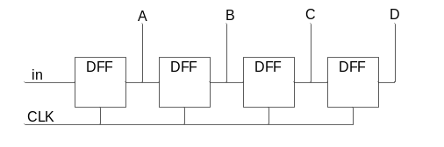

module sifter2 (in, A,B,C, D, clk);
input in, clk;
output A, B,C;
reg A, B, C;
always @ (posedge clk) begin
A = in;
B = A;
D = C;
C = B;
end
endmodule
Solution: Since the assignments here are blocking, this leads to parallel latches. To see why, note that B only updates after A has updated; the blocking assignment assures that. The simulation semantics therefore are that B gets the new value of A, which is to say, in.

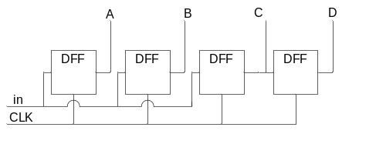
module sifter3 (in, A,B,C, D, clk);
input in, clk;
output A,B,C;
reg A, B, C;
always @ (posedge clk OR reset) begin
A = in;
B = A;
C = B;
D = C;
if (reset) begin A = 0; B = 0; C=0; D=0; end
end
endmodule
Solution: This adds a reset line to the design given in sifter2, as pictured here
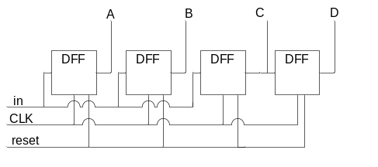
Note that since the always block is evaluated when reset changes, reset is an asynchronous input to each flip-flop;

